**Aiming for Atoms: The Science of Making Smaller Chips**

Bigger numbers are often better in the world of computer chips. *Engineers and users both want more* cores, higher frequencies, and greater FLOPs. There is one measure that is hot in semiconductors right now and it's the smaller the better. The technology node, also known as semiconductor manufacturing, is where you will find the technology node. The process node

What is it exactly and why is it important? It is measured in nanometres. Why are we going all Sesame Street by bringing this article with the numbers 10, 7, and 5?

Let's go on a journey to the world of process nodes...

Before we get into the details, it is worth reading our CPU architecture series. Part one covers the basics of [how they work](https://www.techspot.com/article/1821-how-cpus-are-designed-and-built/), while part 2 focuses on how engineers [design and plan chips](https://www.techspot.com/article/1830-how-cpus-are-designed-and-built-part-2/).

This article's most important section is about how computer chips are [physically assembled](https://www.techspot.com/article/1840-how-cpus-are-designed-and-built-part-3/). If you are interested in a more detailed understanding of the manufacturing process, then you should read the photolithography section. This feature will focus on the point that was briefly mentioned:

The feature size is one of the most commonly used marketing buzzwords in the chip manufacturing industry.

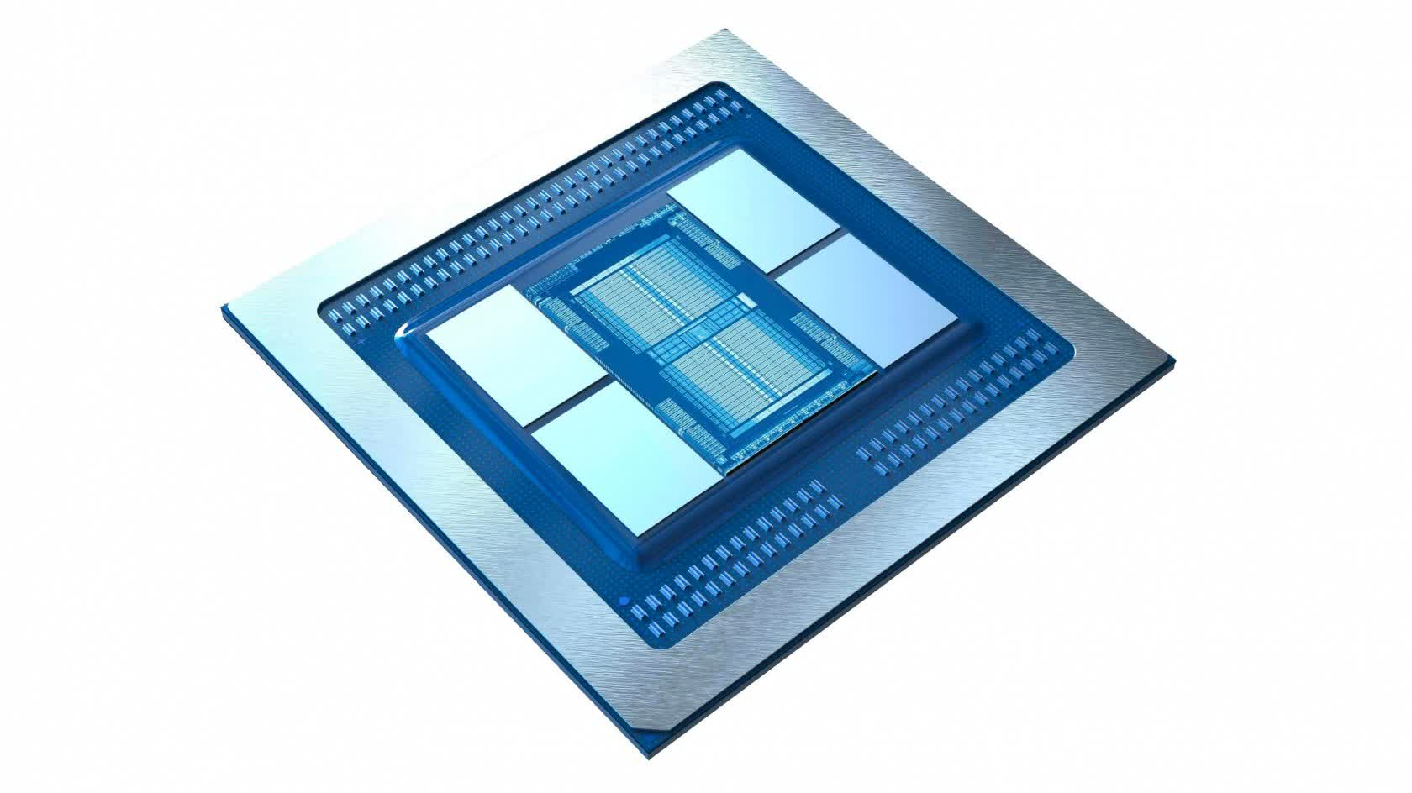

The *process node* is what determines the feature size in the chip industry. [How CPUs Are Designed, Part 3](https://www.techspot.com/article/1840-how-cpus-are-designed-and-built-part-3/)*explains that* is a loose term. Although different manufacturers use this phrase to describe different aspects, it used to refer to the smallest gap between two sections.

Today, it is a marketing term that doesn't really help in comparing production methods. The transistor is an important feature of any processor. Because many transistors perform the computations and storage of data inside the chip, it is very desirable to have a smaller number of these process nodes from the same manufacturer. Why? This is the obvious question.

The world of processors is not instantaneous. It also doesn't happen without the need for electrical energy. It takes longer for larger components to change their states, signals take longer travel time, and it takes more energy to move electricity around the processor. While it may sound confusing, larger components take up more space so chips are also larger.

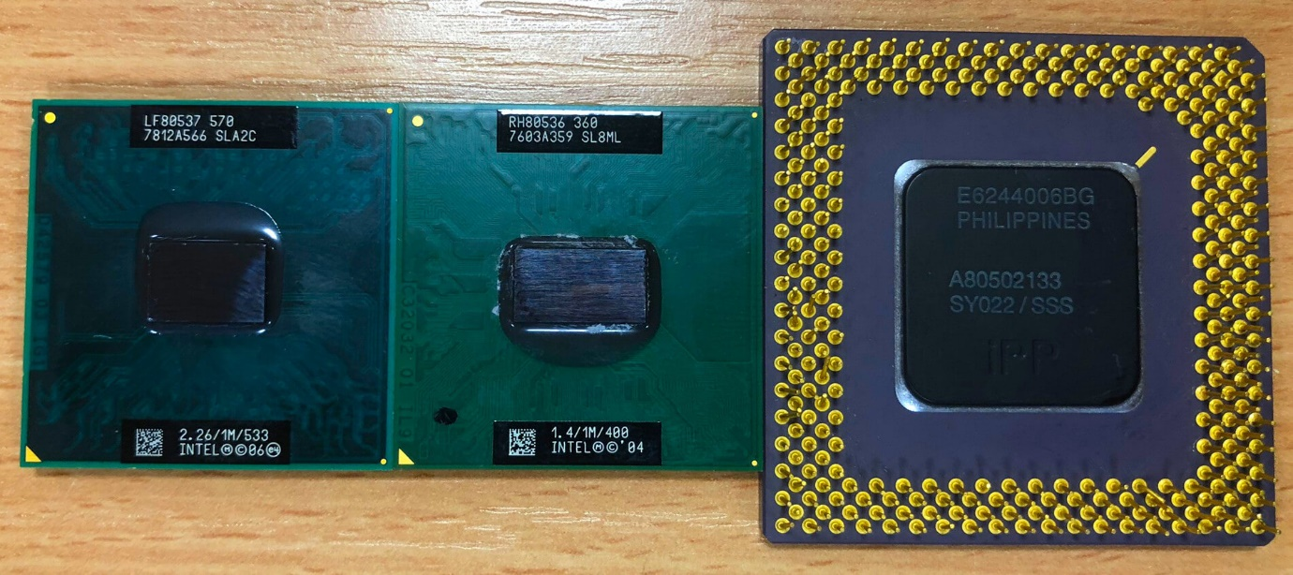

We're looking at three vintage Intel CPUs in the image above. We have a 2006 Celeron, a 2004 Pentium M, and a really ancient Pentium from 1995 starting from the left. Their process nodes are 65, 90, and 350 nanometres, respectively. To put it another way, the key components in the 24-year-old design are more than 5 times larger than those in the 13-year-old design. Another significant difference is that the current chip contains roughly 290 million transistors, compared to little over 3 million in the original Pentium; over a hundred times less.

Although the drop in process node is only half of the reason why the more current architecture is physically smaller and contains more transistors, it is critical to Intel's ability to do so.

But here's the kicker: the Celeron generates only about 30 W of heat, compared to 12 W for the Pentium. As electricity is moved across the circuits in the chip, energy is lost owing to numerous processes, and the vast majority of it is dissipated as heat. Although 30 is a larger number than 12, keep in mind that the device contains roughly 100 times the number of transistors.

If the benefits of having smaller process nodes results in smaller chips that can switch faster, which allows us to do more calculations per second and lose less heat -- it begs another question: *Why isn't every chip using the smallest possible* process node?

**Let there be light!**

At this point, we'll look at a method called photolithography, in which light is sent through a photomask, which blocks light in certain parts while allowing it to flow through in others. The light is then tightly concentrated onto a tiny region where it passes through, and it reacts with a specific layer utilised in the chip's manufacture, assisting in the layout of the various sections.

Consider an x-ray of your hand: the bones function as a photomask, blocking the rays, while the flesh allows them to pass, resulting in a picture of the hand's interior anatomy.

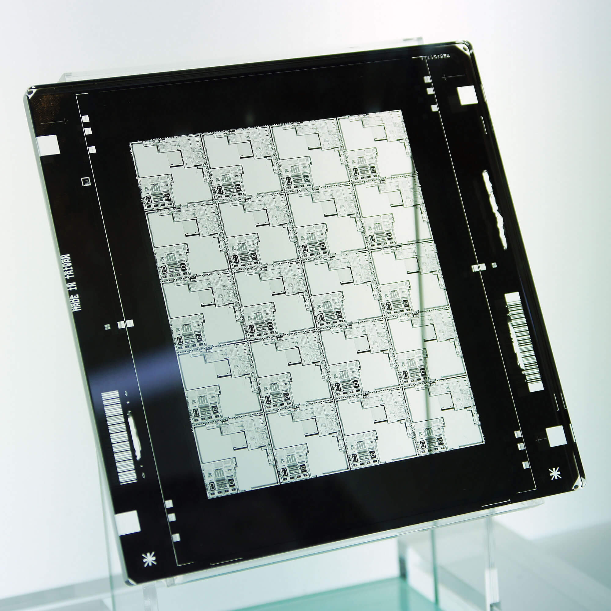

Light isn’t used, even for chips such as the Pentium. It's hard to believe that light can be any size on Earth. But it is in reference to *wavelength*. An *electromagnetic wave* is light, which is a continuously cycling mix of magnetic and electric fields.

While we can see the shape using a traditional sine wave, electromagnetic waves do not have a form. The effect they produce when they interact with another object follows the same pattern. The wavelength of the cyclic pattern refers to the distance between two points that are identical. For example, imagine sea waves rolling onto a beach. The wavelength represents how far the tops of the waves are from each other. We call this a *spectrum* because electromagnetic waves can have many wavelengths.

**Small, Smaller, Smallest**

The image below shows that light, which we call it, is only one part of the spectrum. Other names include radio waves, microwaves and x-rays.

You can also see numbers for wavelengths. Light is approximately 10 -7 meters or 0.000004 in!

Engineers and scientists prefer a different way of describing lengths. It's called nanometres, or "nm", for short. The spectrum's expanded section shows that the light ranges between 380 nm and 750 nm.

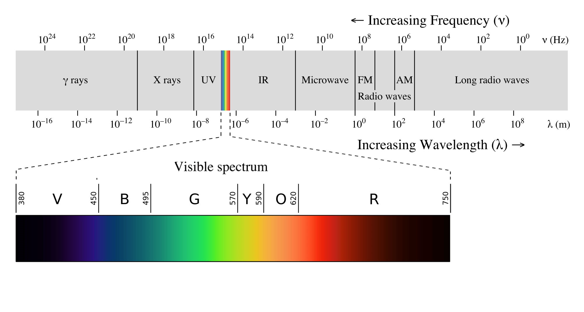

You can go back to this article and read the section about the Celeron chip. It was made on a 65nm process node. How could parts that were smaller than light be manufactured? The photolithography process used ultraviolet light (aka UV) instead of light.

The spectrum chart shows that UV begins at around 380nm (where the light ends off), and shrinks down to 10nm. GlobalFoundries, TSMC and Intel use a type electromagnetic wave called EUV (*extreme* UV). It is approximately 190 nm wide. The tiny waves allow components to be made smaller and can improve their quality. This allows for the parts to be packed closer together, which helps reduce the overall chip size.

Different companies use different names to describe the process nodes they use. Intel calls one of their latest P1274s or "10 nm", while TSMC refers to theirs as "10FF". AMD [is a group of processor designers who create the layouts and structures](https://www.techspot.com/news/77275-amd-launches-zen-2-datacenter-world-first-x86.html) to support the smaller process nodes and then rely on TSMC for their production.

[TSMC](https://www.techspot.com/tag/tsmc/) is diligently working on smaller nodes (7nm-5nm and soon 3nm), and making chips to its largest clients, which include Apple, MediaTek and Qualcomm. Some of the smallest features at this scale of production are only 6 nm in size (most are larger). The silicon atoms which make up the bulk are approximately 0.5 nm apart. The atoms themselves are roughly 0.1 nanometres in diameter. This gives you an idea of how tiny 6 nm is. As a rough guide, TSMC's factories cover aspects of a transistor with less than 10 silicon atoms.

**The difficulty of aiming at atoms**

It is amazing that chip makers are striving to produce features with a few atoms in size. However, EUV photolithography has brought up a lot of engineering and manufacturing issues.

Particularly [, Intel struggled](https://www.techspot.com/community/topics/intel-delays-10nm-mass-production-into-2019.246248/) with its 10 nm production to match their 14 nm one. GlobalFoundries also had problems with its [7 nm](https://www.techspot.com/news/76162-major-globalfoundries-restructuring-underway-abandons-7nm-doubles-down.html) production system and smaller production systems. While Intel's and GF's problems might not be related to EUV photolithography's difficulties, they cannot be separated.

The wavelength of an electromagnetic waves is shorter, meaning that it has more energy. This can lead to chip damage. Small-scale fabrication is also highly susceptible to contamination and defects in materials. Other factors, including diffraction limits (natural variations in the location of the EUV waves' energy being deposited into the chip layer) and statistical noise (natural variations in the energy transfer by the chip layer), can also hinder the goal to create perfect chips.

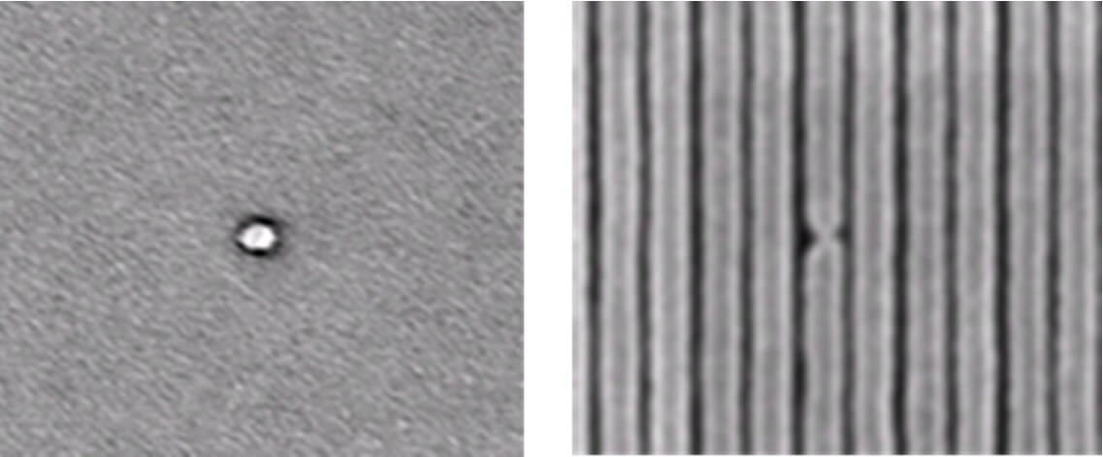

The problem is that the flow of electricity, and the transfer of energy are not controlled by classical systems or rules. Conductors are used to transport electricity in the form electrons, one of three particles that make up an atom. It is easy to wrap conductors in thick insulation.

This is because the insulation isn’t thick enough at the level that Intel and TSMC are working. Production issues are largely related to EUV photolithography. It will take a few years before we can start arguing on forums about how Nvidia handles quantum behaviour better than AMD and other similar nonsense.

The real reason for production problems is that Intel, TSMC, and their fabrication chums, are *businesses* and aim for atoms to generate future revenue. The following outline was provided by Mentor in a [research article](https://www.mentor.com/products/ic_nanometer_design/resources/overview/true-costs-of-process-node-migration-763b6593-de8c-4591-a089-ccd82fe91a23). It explains how much [wafers](https://static.techspot.com/articles-info/1840/images/2019-05-20-image-3.jpg) are more expensive for smaller process nodes.

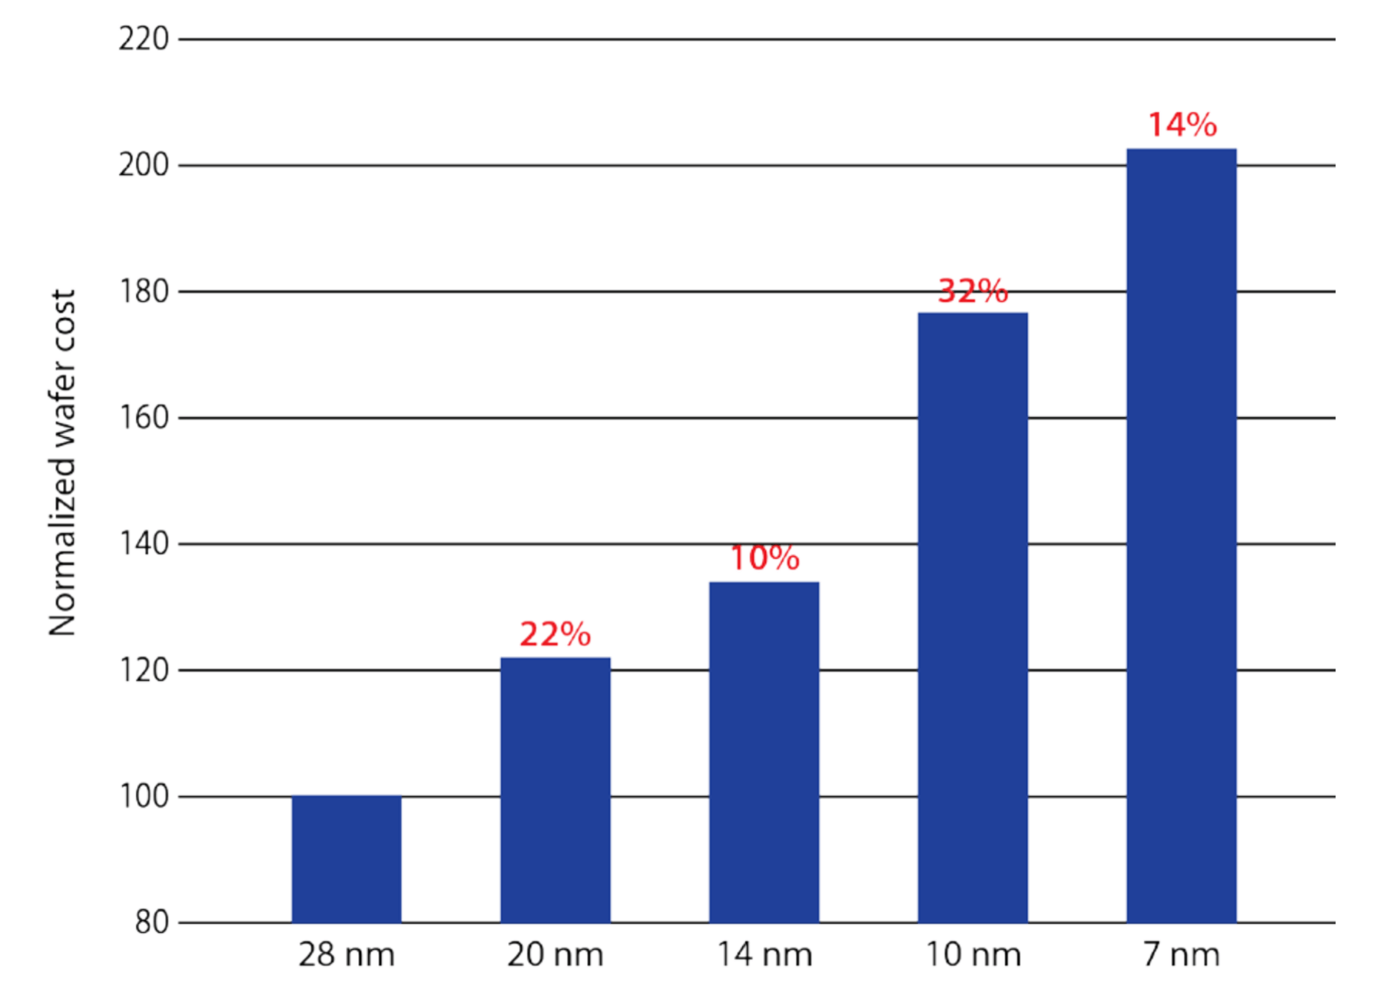

If we assume that the 28 nm process is the same as Intel's Haswell range of CPUs (such the Core i7-4770K), then the 10 nm system costs almost twice as much per wafer. The number of [chips a wafer can produce](https://www.eetimes.com/author.asp?section_id=14&doc_id=1282825) is dependent on the size of each chip. However, a wafer with a smaller process will yield more chips, which can offset the increased costs. The consumer will ultimately pay the highest possible cost by increasing the retail price, but this must be balanced against the industry demand.

Chip manufacturers have had to absorb the financial impact of going to smaller process nodes in order to ensure that the entire system can produce high-yielding wafers. containing as few defects as possible and in large quantities. It's risky business. This is why Global Foundries was forced to bail out of the process node-race.

**Perspectives for the future**

Even though this sounds doom and gloomy, the future is bright. Samsung and TSMC have maintained a healthy margin in 7 nm production for a while. In terms of revenue and volume, chip designers are planning ahead and using multiple nodes in the products.

Other chip manufacturers are replicating AMD's chiplet strategy and design that was first introduced with their [3rd generation Ryzen](https://www.techspot.com/review/1940-amd-ryzen-9-3950x/) CPUs. The AMD desktop processor was made with two chips from TSMC's 7 nm Node and one chip from GlobalFoundries' 14 nm Node. The first part was the processor, while the second handled DDR4 and PCI Express memory attached to the CPU.

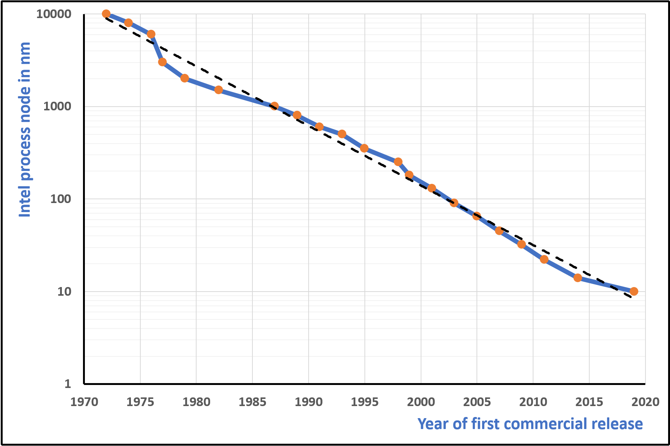

This chart shows Intel's changes in process nodes over the past 50 year. The vertical axis displays the node size in factors of 10, beginning at 10 000 nm. The chip giant used a rough node-half-life of 4.5 years. This is the time it takes to reduce node size by half every time.

Does this mean that we will have a 5nm Intel in 2025? Yes, it is possible, even though they made a mistake with 10nm, and are now working on [getting back](https://www.techspot.com/news/90780-intel-has-reportedly-secured-majority-tsmc-3nm-production.html). Samsung and TSMC are moving forward with their 5 nm production. This is good news for all processors.

They will be smaller, faster, use less energy and have better performance. They will lead the way for fully autonomous cars and smartwatches that have the same power and battery life as current smartphones. Because *small* is the future, it is bright indeed.